Spin-up the WebApp service -

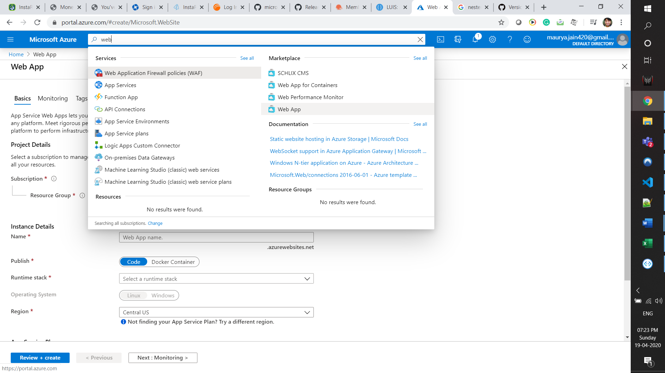

Ensure to choose the free plan if this is trial

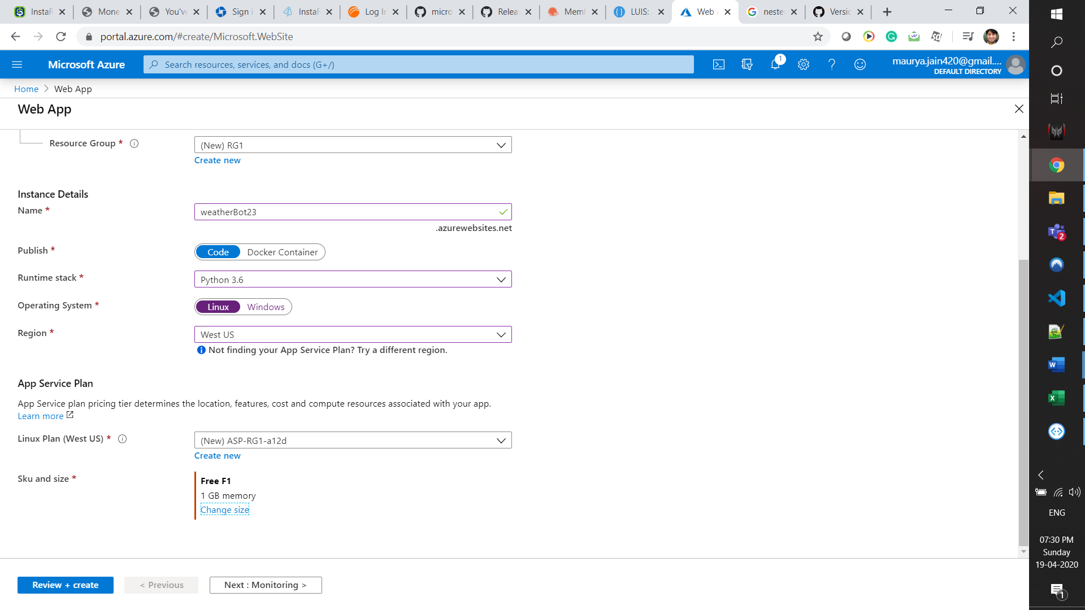

Go to the app and open the Deployment Centre -

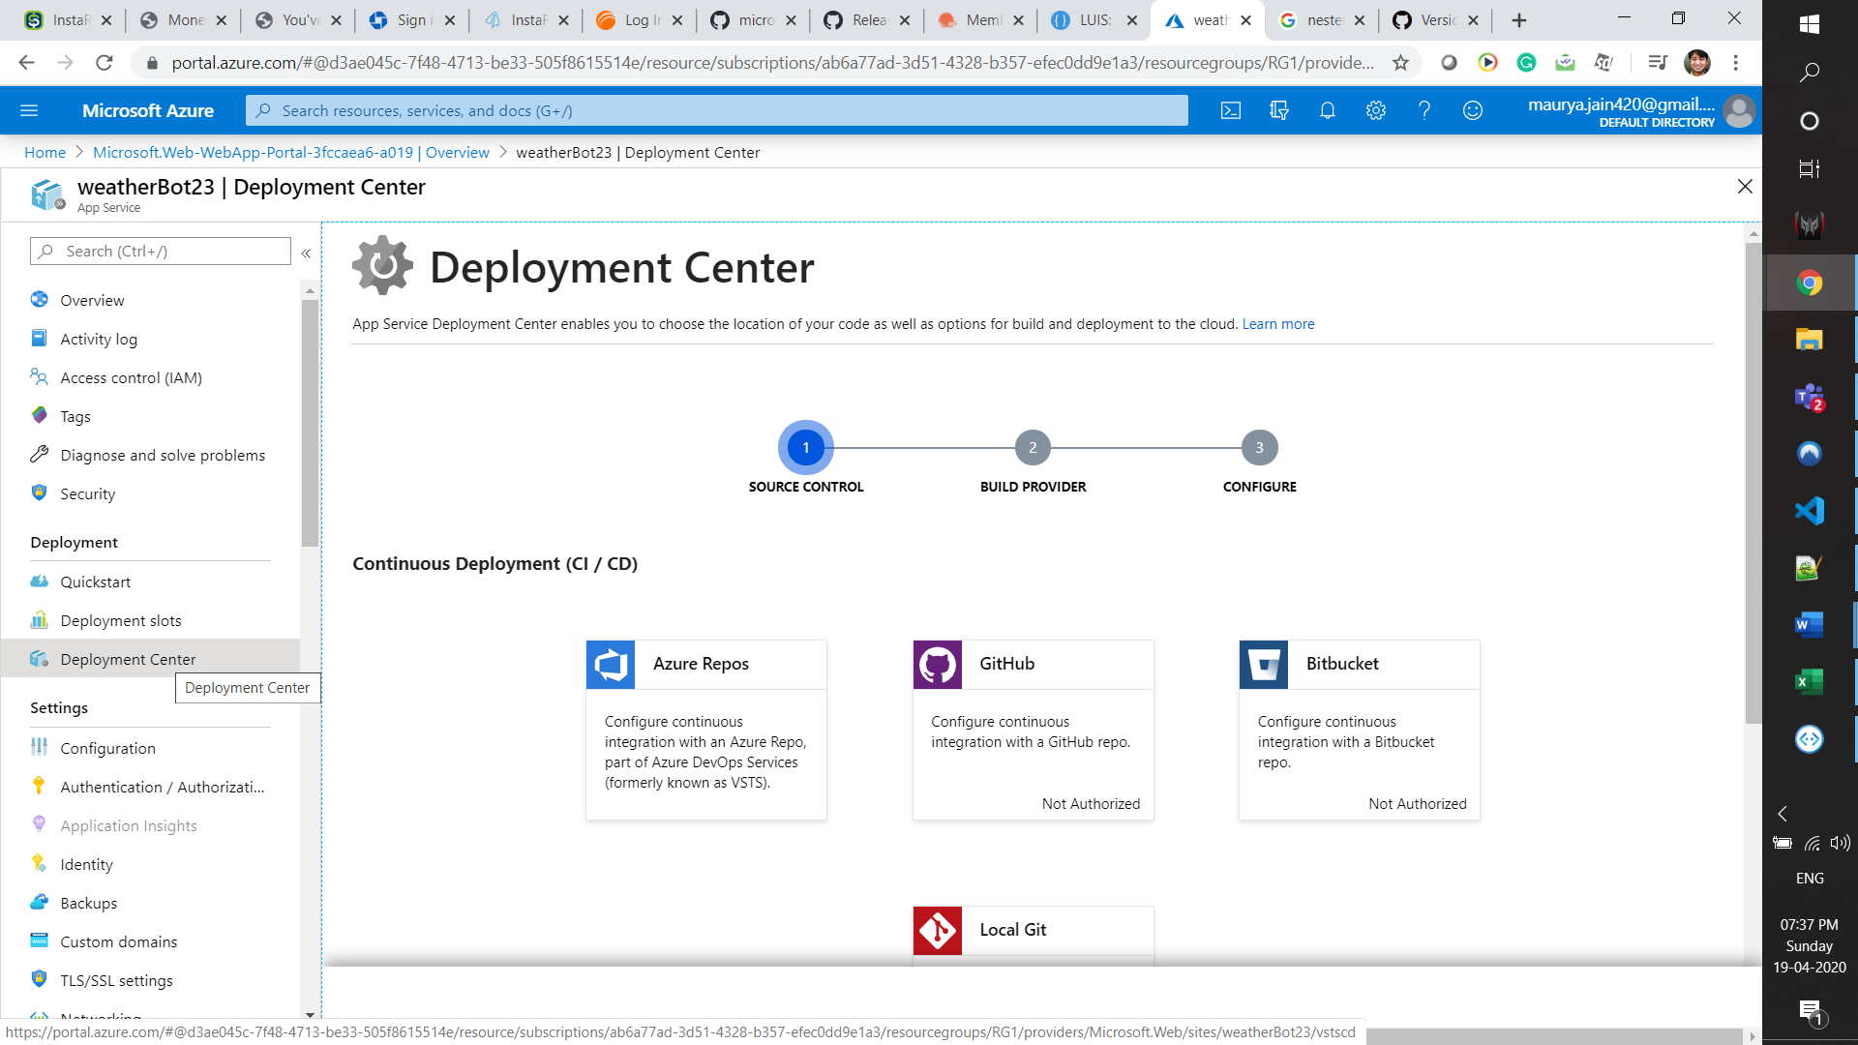

Select local Git under CICD

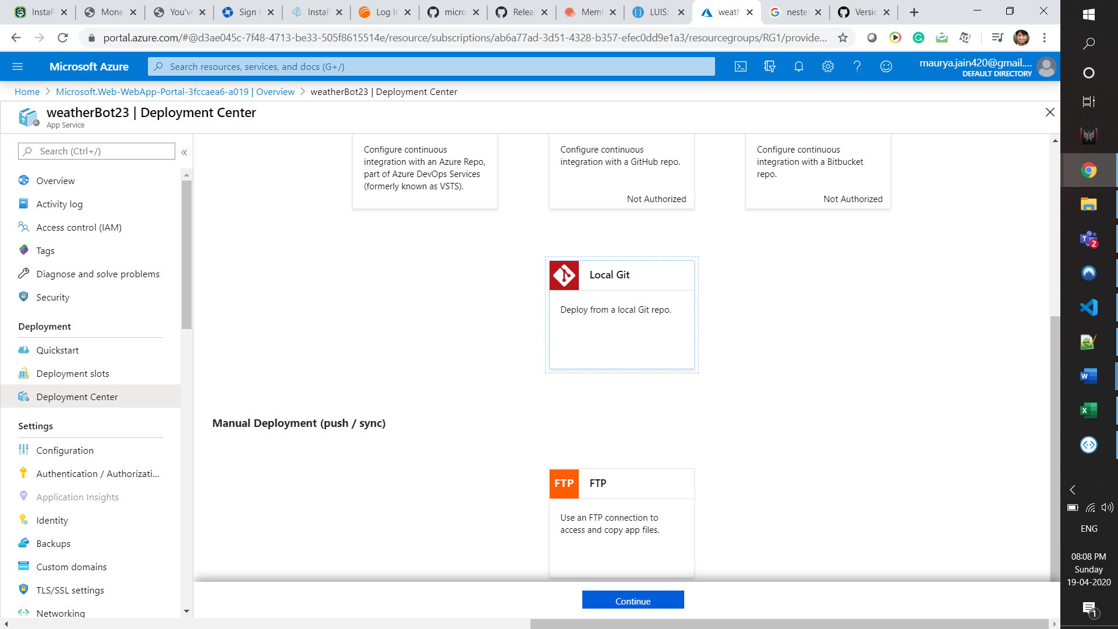

Choose ‘App Service build Service’

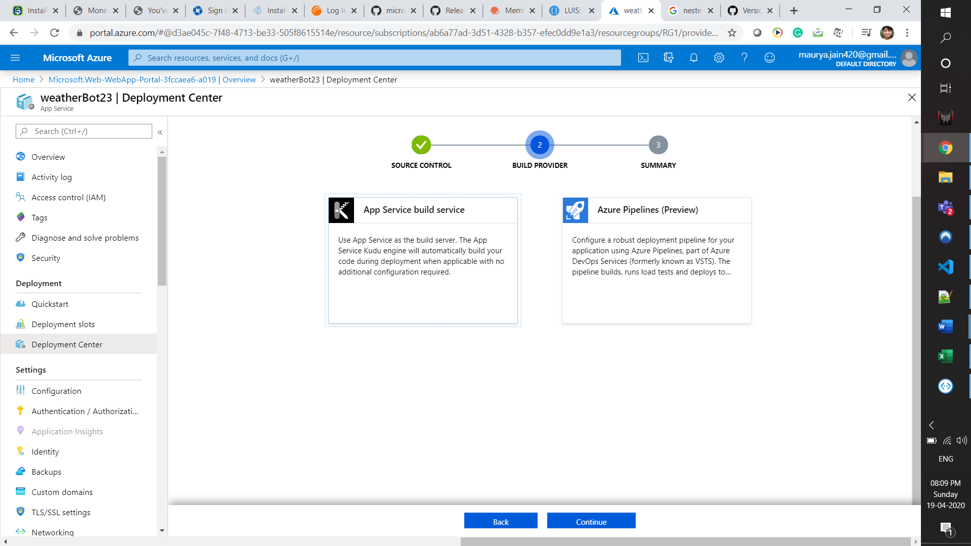

Deploy the App.

Pick the URL of **remote** git repository fro Deployment Center

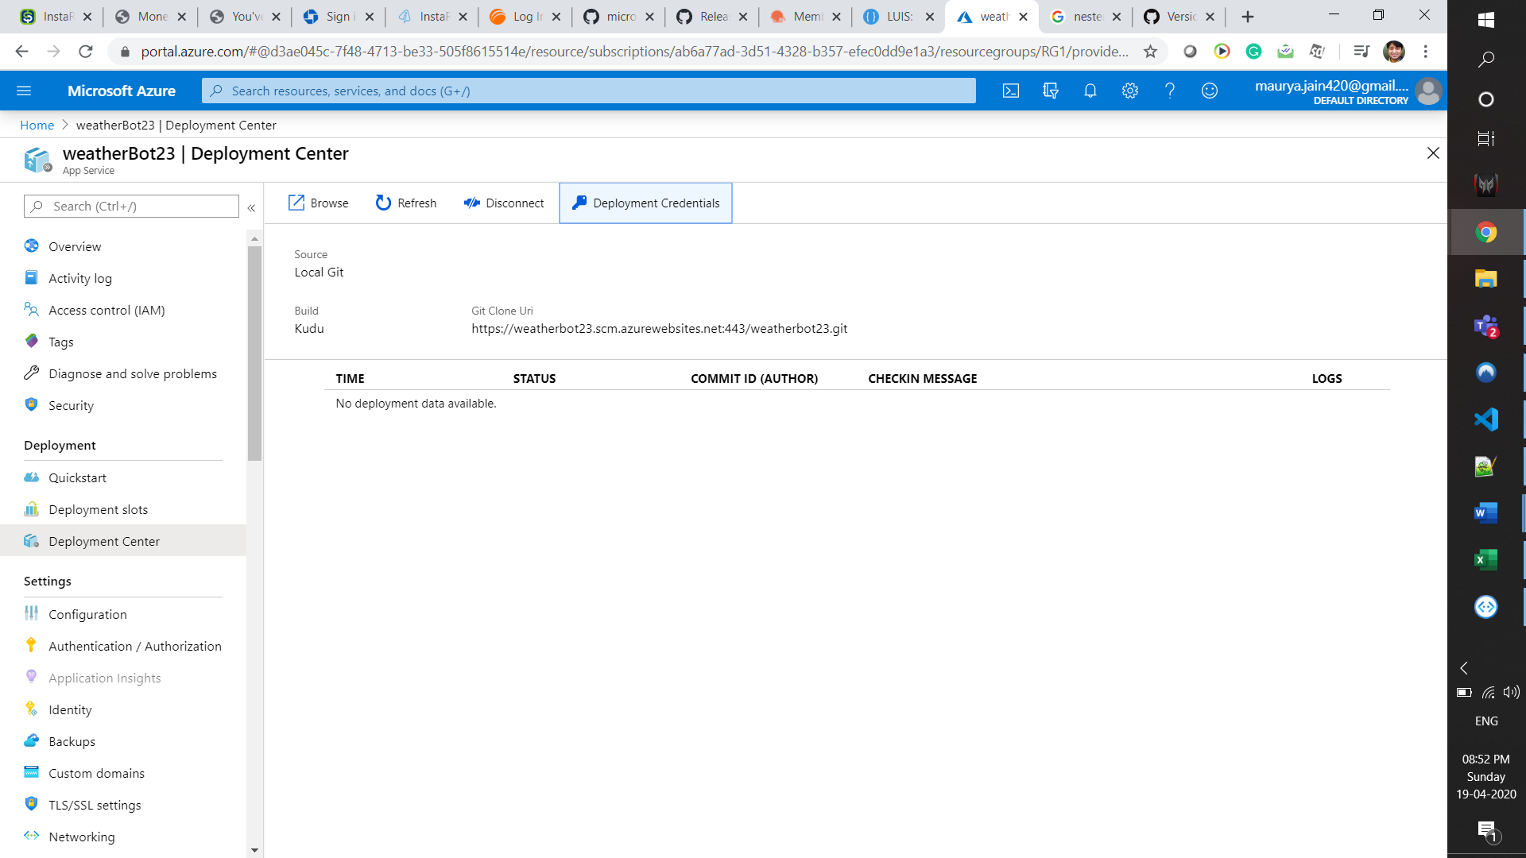

<https://weatherbot23.scm.azurewebsites.net:443/weatherbot23.git>

Note the Deployment Credentials –

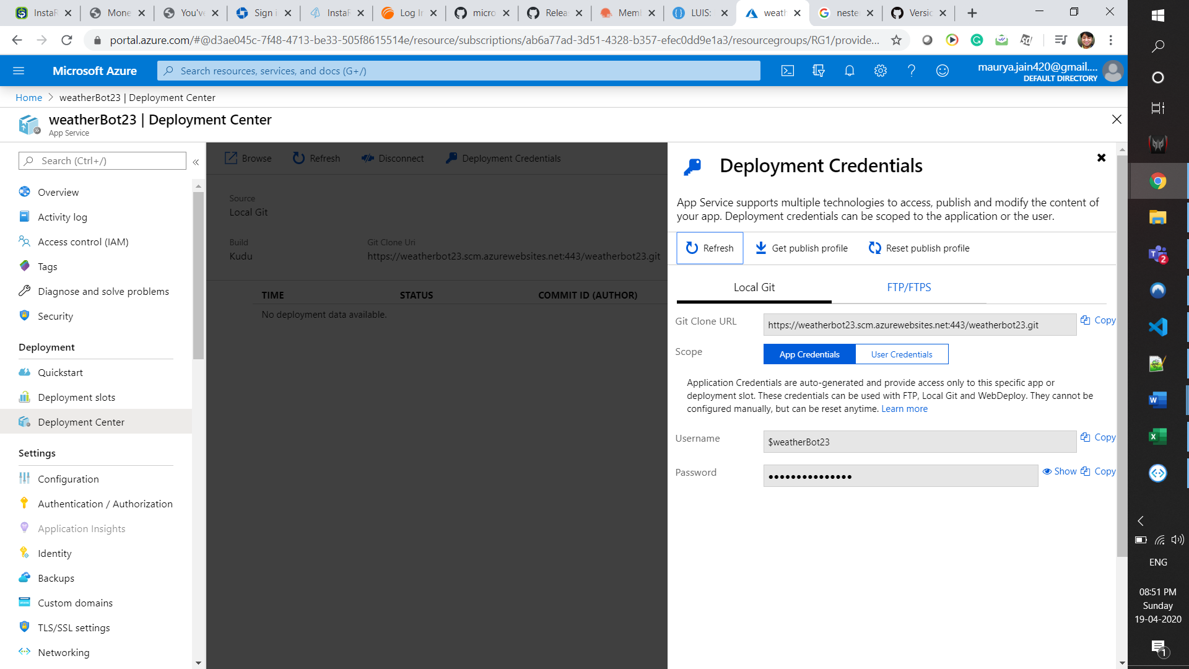

**Username** -> $weatherBot23

**Password** -> rZ8NWB60rcA0uN3qukurncSDKlBETBc7DBoavGPtHSpMqi2J4yjDPj5LKaY6

We now need to push the code from local git repo to remote git repo –

* Open a command prompt and navigate to your project folder.
* Run git init to initialize an empty git repository
* Create a new remote git alias using the command: git remote add <alias> <git clone url> . Choose any aliasname.
* Use git add . to add all the files to the local git repository.
* Use git commit –m “First Commit” to commit the code to the local git repo.
* Push the code to the remote repo using git push <alias> master –f
* This prompts for a username and password. Go to the ‘Deployment Credentials’ section and copy the username and password to enter in the prompt.

**Log –**

Microsoft Windows [Version 10.0.18363.778]

(c) 2019 Microsoft Corporation. All rights reserved.

C:\WINDOWS\system32>d:

D:\>cd Ayush\MyWiki\Data-Science\Applications\Chatbot\Azure Luis-Weather

D:\Ayush\MyWiki\Data-Science\Applications\Chatbot\Azure Luis-Weather>git init

Initialized empty Git repository in D:/Ayush/MyWiki/Data-Science/Applications/Chatbot/Azure Luis-Weather/.git/

D:\Ayush\MyWiki\Data-Science\Applications\Chatbot\Azure Luis-Weather>git remote add azbot https://weatherbot23.scm.azurewebsites.net:443/weatherbot23.git

D:\Ayush\MyWiki\Data-Science\Applications\Chatbot\Azure Luis-Weather>git add .

warning: LF will be replaced by CRLF in .idea/inspectionProfiles/profiles_settings.xml.

The file will have its original line endings in your working directory

warning: LF will be replaced by CRLF in .idea/misc.xml.

The file will have its original line endings in your working directory

D:\Ayush\MyWiki\Data-Science\Applications\Chatbot\Azure Luis-Weather>commit -m "First Commit"

'commit' is not recognized as an internal or external command,

operable program or batch file.

D:\Ayush\MyWiki\Data-Science\Applications\Chatbot\Azure Luis-Weather>git commit -m "First Commit"

[master (root-commit) f62acd0] First Commit

32 files changed, 294 insertions(+)

create mode 100644 .idea/.gitignore

create mode 100644 .idea/Azure Luis-Weather.iml

create mode 100644 .idea/inspectionProfiles/profiles_settings.xml

create mode 100644 .idea/misc.xml

create mode 100644 .idea/modules.xml

create mode 100644 .idea/vcs.xml

create mode 100644 .vscode/settings.json

create mode 100644 AzureChatbot Config Steps.docx

create mode 100644 Procfile

create mode 100644 README.md

create mode 100644 app.py

create mode 100644 config.ini

create mode 100644 config/__pycache__/config_reader.cpython-36.pyc

create mode 100644 config/__pycache__/config_reader.cpython-37.pyc

create mode 100644 config/config_reader.py

create mode 100644 conversationLogs/dummy

create mode 100644 conversationLogs/session1.txt

create mode 100644 documentation/azureWeatherBot.docx

create mode 100644 documentation/~$ureWeatherBot.docx

create mode 100644 documentation/~WRL2201.tmp

create mode 100644 logger/__pycache__/logger.cpython-36.pyc

create mode 100644 logger/__pycache__/logger.cpython-37.pyc

create mode 100644 logger/logger.py

create mode 100644 luis/__pycache__/luisApp.cpython-36.pyc

create mode 100644 luis/__pycache__/luisApp.cpython-37.pyc

create mode 100644 luis/luisApp.py

create mode 100644 requirements.txt

create mode 100644 weather/__pycache__/weatherApp.cpython-36.pyc

create mode 100644 weather/__pycache__/weatherApp.cpython-37.pyc

create mode 100644 weather/weatherApp.py

create mode 100644 ~$ureChatbot Config Steps.docx

create mode 100644 ~WRL3330.tmp

D:\Ayush\MyWiki\Data-Science\Applications\Chatbot\Azure Luis-Weather>git push azbot master-f

error: src refspec master-f does not match any

error: failed to push some refs to 'https://weatherbot23.scm.azurewebsites.net:443/weatherbot23.git'

D:\Ayush\MyWiki\Data-Science\Applications\Chatbot\Azure Luis-Weather>git push azbot master -f

Enumerating objects: 47, done.

Counting objects: 100% (47/47), done.

Delta compression using up to 8 threads

Compressing objects: 100% (41/41), done.

Writing objects: 100% (47/47), 3.92 MiB | 346.00 KiB/s, done.

Total 47 (delta 6), reused 0 (delta 0), pack-reused 0

remote: Deploy Async

remote: Updating branch 'master'.

remote: Updating submodules.

remote: Preparing deployment for commit id 'f62acd0aa2'.

remote: Repository path is /home/site/repository

remote: Running oryx build...

remote: Build orchestrated by Microsoft Oryx, https://github.com/Microsoft/Oryx

remote: You can report issues at https://github.com/Microsoft/Oryx/issues

remote:

remote: Oryx Version : 0.2.20200114.13, Commit: 204922f30f8e8d41f5241b8c218425ef89106d1d, ReleaseTagName: 20200114.13

remote: Build Operation ID: |7GRxT4kLyDA=.7f363e8_

remote: Repository Commit : f62acd0aa2169895beae3a5e735adcdf62ca0d57

remote:

remote: Warning: An outdated version of python was detected (3.6.9). Consider updating.\nVersions supported by Oryx: https://github.com/microsoft/Oryx

remote:

remote: Using intermediate directory '/tmp/8d7e477516dcc7b'.

remote:

remote: Copying files to the intermediate directory...

remote: Done in 0 sec(s).

remote:

remote: Source directory : /tmp/8d7e477516dcc7b

remote: Destination directory: /home/site/wwwroot

remote:

remote: Python Version: /opt/python/3.6.9/bin/python3

remote: Python Virtual Environment: antenv3.6

remote: Creating virtual environment ...

remote: ....

remote: Activating virtual environment ...

remote:

remote: Upgrading pip...

remote: Collecting pip

remote: Downloading https://files.pythonhosted.org/packages/54/0c/d01aa759fdc501a58f431eb594a17495f15b88da142ce14b5845662c13f3/pip-20.0.2-py2.py3-none-any.whl (1.4MB)

remote: Installing collected packages: pip

remote: Found existing installation: pip 18.1

remote: Uninstalling pip-18.1:

remote: Successfully uninstalled pip-18.1

remote: Successfully installed pip-20.0.2

remote: Done in 9 sec(s).

remote: Running pip install...

remote: [15:36:05+0000] Collecting adal==1.2.1

remote: [15:36:05+0000] Downloading adal-1.2.1-py2.py3-none-any.whl (52 kB)

remote: [15:36:07+0000] Collecting aiohttp==3.6.2

remote: [15:36:07+0000] Downloading aiohttp-3.6.2-cp36-cp36m-manylinux1_x86_64.whl (1.2 MB)

remote: [15:36:07+0000] Collecting aiounittest==1.3.0

remote: [15:36:07+0000] Downloading aiounittest-1.3.0.tar.gz (5.4 kB)

remote: [15:36:11+0000] Collecting applicationinsights==0.11.9

remote: [15:36:11+0000] Downloading applicationinsights-0.11.9-py2.py3-none-any.whl (58 kB)

remote: [15:36:11+0000] Collecting APScheduler==3.6.3

remote: [15:36:11+0000] Downloading APScheduler-3.6.3-py2.py3-none-any.whl (58 kB)

remote: [15:36:11+0000] Collecting async-timeout==3.0.1

remote: [15:36:11+0000] Downloading async_timeout-3.0.1-py3-none-any.whl (8.2 kB)

remote: [15:36:11+0000] Collecting attrs==19.3.0

remote: [15:36:11+0000] Downloading attrs-19.3.0-py2.py3-none-any.whl (39 kB)

remote: [15:36:12+0000] Collecting azure-cognitiveservices-language-luis==0.2.0

remote: [15:36:12+0000] Downloading azure_cognitiveservices_language_luis-0.2.0-py2.py3-none-any.whl (244 kB)

remote: [15:36:12+0000] Collecting azure-common==1.1.25

remote: [15:36:12+0000] Downloading azure_common-1.1.25-py2.py3-none-any.whl (12 kB)

remote: [15:36:12+0000] Collecting azure-cosmos==3.1.2

remote: [15:36:12+0000] Downloading azure_cosmos-3.1.2-py3-none-any.whl (140 kB)

remote: [15:36:12+0000] Collecting azure-storage-blob==2.1.0

remote: [15:36:12+0000] Downloading azure_storage_blob-2.1.0-py2.py3-none-any.whl (88 kB)

remote: [15:36:13+0000] Collecting azure-storage-common==2.1.0

remote: [15:36:13+0000] Downloading azure_storage_common-2.1.0-py2.py3-none-any.whl (47 kB)

remote: [15:36:13+0000] Collecting Babel==2.7.0

remote: [15:36:13+0000] Downloading Babel-2.7.0-py2.py3-none-any.whl (8.4 MB)

remote: [15:36:16+0000] Collecting botbuilder-ai==4.8.0

remote: [15:36:16+0000] Downloading botbuilder_ai-4.8.0-py3-none-any.whl (32 kB)

remote: [15:36:16+0000] Collecting botbuilder-applicationinsights==4.8.0

remote: [15:36:16+0000] Downloading botbuilder_applicationinsights-4.8.0-py3-none-any.whl (18 kB)

remote: [15:36:16+0000] Collecting botbuilder-azure==4.8.0

remote: [15:36:16+0000] Downloading botbuilder_azure-4.8.0-py3-none-any.whl (11 kB)

remote: [15:36:16+0000] Collecting botbuilder-core==4.8.0

remote: [15:36:16+0000] Downloading botbuilder_core-4.8.0-py3-none-any.whl (84 kB)

remote: [15:36:17+0000] Collecting botbuilder-dialogs==4.8.0

remote: [15:36:17+0000] Downloading botbuilder_dialogs-4.8.0-py3-none-any.whl (60 kB)

remote: [15:36:17+0000] Collecting botbuilder-schema==4.8.0

remote: [15:36:17+0000] Downloading botbuilder_schema-4.8.0-py2.py3-none-any.whl (47 kB)

remote: [15:36:17+0000] Collecting botframework-connector==4.8.0

remote: [15:36:17+0000] Downloading botframework_connector-4.8.0-py2.py3-none-any.whl (68 kB)

remote: [15:36:17+0000] Collecting certifi==2019.11.28

remote: [15:36:17+0000] Downloading certifi-2019.11.28-py2.py3-none-any.whl (156 kB)

remote: [15:36:18+0000] Collecting cffi==1.14.0

remote: [15:36:19+0000] Downloading cffi-1.14.0-cp36-cp36m-manylinux1_x86_64.whl (399 kB)

remote: [15:36:19+0000] Collecting chardet==3.0.4

remote: [15:36:19+0000] Downloading chardet-3.0.4-py2.py3-none-any.whl (133 kB)

remote: [15:36:19+0000] Collecting Click==7.0

remote: [15:36:19+0000] Downloading Click-7.0-py2.py3-none-any.whl (81 kB)

remote: [15:36:20+0000] Collecting colorhash==1.0.2

remote: [15:36:20+0000] Downloading colorhash-1.0.2-py2.py3-none-any.whl (6.0 kB)

remote: [15:36:20+0000] Collecting configparser==4.0.2

remote: [15:36:20+0000] Downloading configparser-4.0.2-py2.py3-none-any.whl (22 kB)

remote: [15:36:21+0000] Collecting cryptography==2.8

remote: [15:36:21+0000] Downloading cryptography-2.8-cp34-abi3-manylinux2010_x86_64.whl (2.3 MB)

remote: [15:36:22+0000] Collecting cycler==0.10.0

remote: [15:36:22+0000] Downloading cycler-0.10.0-py2.py3-none-any.whl (6.5 kB)

remote: [15:36:22+0000] Collecting datedelta==1.3

remote: [15:36:22+0000] Downloading datedelta-1.3-py3-none-any.whl (6.7 kB)

remote: [15:36:22+0000] Collecting Django==2.2.6

remote: [15:36:22+0000] Downloading Django-2.2.6-py3-none-any.whl (7.5 MB)

remote: ............

remote: [15:36:38+0000] Collecting djangorestframework==3.10.3

remote: [15:36:38+0000] Downloading djangorestframework-3.10.3-py3-none-any.whl (909 kB)

remote: [15:36:39+0000] Collecting emoji==0.5.4

remote: [15:36:39+0000] Downloading emoji-0.5.4.tar.gz (43 kB)

remote: [15:36:40+0000] Collecting Flask==1.1.1

remote: [15:36:40+0000] Downloading Flask-1.1.1-py2.py3-none-any.whl (94 kB)

remote: [15:36:44+0000] Collecting Flask-Cors==3.0.8

remote: [15:36:44+0000] Downloading Flask_Cors-3.0.8-py2.py3-none-any.whl (14 kB)

remote: [15:36:45+0000] Collecting Flask-MonitoringDashboard==3.0.6

remote: [15:36:45+0000] Downloading Flask-MonitoringDashboard-3.0.6.tar.gz (217 kB)

remote: [15:36:46+0000] Collecting geojson==2.5.0

remote: [15:36:46+0000] Downloading geojson-2.5.0-py2.py3-none-any.whl (14 kB)

remote: [15:36:46+0000] Collecting grapheme==0.6.0

remote: [15:36:46+0000] Downloading grapheme-0.6.0.tar.gz (207 kB)

remote: [15:36:47+0000] Collecting gunicorn==20.0.4

remote: [15:36:47+0000] Downloading gunicorn-20.0.4-py2.py3-none-any.whl (77 kB)

remote: [15:36:47+0000] Collecting idna==2.8

remote: [15:36:47+0000] Downloading idna-2.8-py2.py3-none-any.whl (58 kB)

remote: [15:36:47+0000] Collecting isodate==0.6.0

remote: [15:36:47+0000] Downloading isodate-0.6.0-py2.py3-none-any.whl (45 kB)

remote: [15:36:48+0000] Collecting itsdangerous==1.1.0

remote: [15:36:48+0000] Downloading itsdangerous-1.1.0-py2.py3-none-any.whl (16 kB)

remote: [15:36:48+0000] Collecting Jinja2==2.11.0

remote: [15:36:48+0000] Downloading Jinja2-2.11.0-py2.py3-none-any.whl (126 kB)

remote: [15:36:48+0000] Collecting jsonpickle==1.2

remote: [15:36:48+0000] Downloading jsonpickle-1.2-py2.py3-none-any.whl (32 kB)

remote: [15:36:48+0000] Collecting kiwisolver==1.1.0

remote: [15:36:48+0000] Downloading kiwisolver-1.1.0-cp36-cp36m-manylinux1_x86_64.whl (90 kB)

remote: [15:36:48+0000] Collecting kneed==0.5.3

remote: [15:36:48+0000] Downloading kneed-0.5.3-py2.py3-none-any.whl (10 kB)

remote: [15:36:48+0000] Collecting MarkupSafe==1.1.1

remote: [15:36:48+0000] Downloading MarkupSafe-1.1.1-cp36-cp36m-manylinux1_x86_64.whl (27 kB)

remote: [15:36:48+0000] Collecting msal==1.1.0

remote: [15:36:48+0000] Downloading msal-1.1.0-py2.py3-none-any.whl (44 kB)

remote: [15:36:49+0000] Collecting msrest==0.6.10

remote: [15:36:49+0000] Downloading msrest-0.6.10-py2.py3-none-any.whl (82 kB)

remote: [15:36:49+0000] Collecting msrestazure==0.6.3

remote: [15:36:49+0000] Downloading msrestazure-0.6.3-py2.py3-none-any.whl (40 kB)

remote: [15:36:50+0000] Collecting multidict==4.7.5

remote: [15:36:50+0000] Downloading multidict-4.7.5-cp36-cp36m-manylinux1_x86_64.whl (148 kB)

remote: [15:36:51+0000] Collecting multipledispatch==0.6.0

remote: [15:36:51+0000] Downloading multipledispatch-0.6.0-py3-none-any.whl (11 kB)

remote: [15:36:51+0000] Collecting oauthlib==3.1.0

remote: [15:36:51+0000] Downloading oauthlib-3.1.0-py2.py3-none-any.whl (147 kB)

remote: [15:36:52+0000] Collecting psutil==5.7.0

remote: [15:36:52+0000] Downloading psutil-5.7.0.tar.gz (449 kB)

remote: [15:36:54+0000] Collecting pycparser==2.20

remote: [15:36:54+0000] Downloading pycparser-2.20-py2.py3-none-any.whl (112 kB)

remote: [15:36:54+0000] Collecting PyJWT==1.5.3

remote: [15:36:54+0000] Downloading PyJWT-1.5.3-py2.py3-none-any.whl (17 kB)

remote: [15:36:54+0000] Collecting pyowm==2.10.0

remote: [15:36:54+0000] Downloading pyowm-2.10.0-py3-none-any.whl (3.7 MB)

remote: [15:36:57+0000] Collecting pyparsing==2.4.6

remote: [15:36:57+0000] Downloading pyparsing-2.4.6-py2.py3-none-any.whl (67 kB)

remote: [15:36:57+0000] Collecting python-dateutil==2.8.1

remote: [15:36:57+0000] Downloading python_dateutil-2.8.1-py2.py3-none-any.whl (227 kB)

remote: [15:36:58+0000] Collecting pytz==2019.3

remote: [15:36:58+0000] Downloading pytz-2019.3-py2.py3-none-any.whl (509 kB)

remote: [15:36:58+0000] Collecting recognizers-text==1.0.2a2

remote: [15:36:58+0000] Downloading recognizers_text-1.0.2a2-py3-none-any.whl (14 kB)

remote: [15:36:59+0000] Collecting recognizers-text-choice==1.0.2a2

remote: [15:36:59+0000] Downloading recognizers_text_choice-1.0.2a2-py3-none-any.whl (8.0 kB)

remote: [15:36:59+0000] Collecting recognizers-text-date-time==1.0.2a2

remote: [15:36:59+0000] Downloading recognizers_text_date_time-1.0.2a2-py3-none-any.whl (248 kB)

remote: [15:36:59+0000] Collecting recognizers-text-number==1.0.2a2

remote: [15:36:59+0000] Downloading recognizers_text_number-1.0.2a2-py3-none-any.whl (60 kB)

remote: [15:36:59+0000] Collecting recognizers-text-number-with-unit==1.0.2a2

remote: [15:36:59+0000] Downloading recognizers_text_number_with_unit-1.0.2a2-py3-none-any.whl (75 kB)

remote: [15:37:01+0000] Collecting regex==2019.8.19

remote: [15:37:01+0000] Downloading regex-2019.08.19.tar.gz (654 kB)

remote: [15:37:03+0000] Collecting requests==2.22.0

remote: [15:37:03+0000] Downloading requests-2.22.0-py2.py3-none-any.whl (57 kB)

remote: [15:37:03+0000] Collecting requests-oauthlib==1.3.0

remote: [15:37:03+0000] Downloading requests_oauthlib-1.3.0-py2.py3-none-any.whl (23 kB)

remote: [15:37:03+0000] Collecting six==1.14.0

remote: [15:37:03+0000] Downloading six-1.14.0-py2.py3-none-any.whl (10 kB)

remote: [15:37:04+0000] Collecting SQLAlchemy==1.3.13

remote: [15:37:04+0000] Downloading SQLAlchemy-1.3.13.tar.gz (6.0 MB)

remote: ......

remote: [15:37:14+0000] Collecting sqlparse==0.3.1

remote: [15:37:14+0000] Downloading sqlparse-0.3.1-py2.py3-none-any.whl (40 kB)

remote: [15:37:15+0000] Collecting tzlocal==2.0.0

remote: [15:37:15+0000] Downloading tzlocal-2.0.0-py2.py3-none-any.whl (15 kB)

remote: [15:37:15+0000] Collecting urllib3==1.25.8

remote: [15:37:15+0000] Downloading urllib3-1.25.8-py2.py3-none-any.whl (125 kB)

remote: [15:37:15+0000] Collecting Werkzeug==0.16.1

remote: [15:37:15+0000] Downloading Werkzeug-0.16.1-py2.py3-none-any.whl (327 kB)

remote: [15:37:16+0000] Collecting wincertstore==0.2

remote: [15:37:16+0000] Downloading wincertstore-0.2-py2.py3-none-any.whl (8.8 kB)

remote: [15:37:16+0000] Collecting yarl==1.4.2

remote: [15:37:16+0000] Downloading yarl-1.4.2-cp36-cp36m-manylinux1_x86_64.whl (252 kB)

remote: [15:37:16+0000] Collecting typing-extensions>=3.6.5; python_version < "3.7"

remote: [15:37:16+0000] Downloading typing_extensions-3.7.4.2-py3-none-any.whl (22 kB)

remote: [15:37:17+0000] Collecting idna-ssl>=1.0; python_version < "3.7"

remote: [15:37:17+0000] Downloading idna-ssl-1.1.0.tar.gz (3.4 kB)

remote: [15:37:18+0000] Requirement already satisfied: setuptools>=0.7 in ./antenv3.6/lib/python3.6/site-packages (from APScheduler==3.6.3->-r requirements.txt (line 5)) (40.6.2)

remote: .

remote: [15:37:23+0000] Collecting numpy

remote: [15:37:23+0000] Downloading numpy-1.18.2-cp36-cp36m-manylinux1_x86_64.whl (20.2 MB)

remote: ...

remote: [15:37:37+0000] Collecting matplotlib

remote: [15:37:37+0000] Downloading matplotlib-3.2.1-cp36-cp36m-manylinux1_x86_64.whl (12.4 MB)

remote: ...............

remote: [15:37:57+0000] Collecting scipy

remote: [15:37:57+0000] Downloading scipy-1.4.1-cp36-cp36m-manylinux1_x86_64.whl (26.1 MB)

remote: .......

remote: ..........

remote: [15:38:23+0000] Collecting scikit-learn

remote: [15:38:23+0000] Downloading scikit_learn-0.22.2.post1-cp36-cp36m-manylinux1_x86_64.whl (7.1 MB)

remote: .......

remote: [15:38:35+0000] Collecting joblib>=0.11

remote: [15:38:35+0000] Downloading joblib-0.14.1-py2.py3-none-any.whl (294 kB)

remote: [15:38:37+0000] Installing collected packages: PyJWT, six, python-dateutil, urllib3, idna, chardet, certifi, requests, pycparser, cffi, cryptography, adal, typing-extensions, async-timeout, attrs, idna-ssl, multidict, yarl, aiohttp, aiounittest, applicationinsights, pytz, tzlocal, APScheduler, isodate, oauthlib, requests-oauthlib, msrest, msrestazure, azure-common, azure-cognitiveservices-language-luis, azure-cosmos, azure-storage-common, azure-storage-blob, Babel, botbuilder-schema, msal, botframework-connector, jsonpickle, botbuilder-core, botbuilder-ai, sqlparse, Django, Click, Werkzeug, MarkupSafe, Jinja2, itsdangerous, Flask, djangorestframework, botbuilder-applicationinsights, botbuilder-azure, grapheme, emoji, multipledispatch, recognizers-text, regex, recognizers-text-choice, recognizers-text-number, recognizers-text-number-with-unit, datedelta, recognizers-text-date-time, botbuilder-dialogs, colorhash, configparser, cycler, Flask-Cors, SQLAlchemy, psutil, numpy, Flask-MonitoringDashboard, geojson, gunicorn, kiwisolver, pyparsing, matplotlib, scipy, joblib, scikit-learn, kneed, pyowm, wincertstore

remote: ..

remote: [15:38:43+0000] Running setup.py install for idna-ssl: started

remote: [15:38:45+0000] Running setup.py install for idna-ssl: finished with status 'done'

remote: [15:38:46+0000] Running setup.py install for aiounittest: started

remote: [15:38:48+0000] Running setup.py install for aiounittest: finished with status 'done'

remote: ...........................................

remote: [15:39:36+0000] Running setup.py install for grapheme: started

remote: [15:39:37+0000] Running setup.py install for grapheme: finished with status 'done'

remote: [15:39:37+0000] Running setup.py install for emoji: started

remote: [15:39:38+0000] Running setup.py install for emoji: finished with status 'done'

remote: [15:39:38+0000] Running setup.py install for regex: started

remote: ................................

remote: [15:40:15+0000] Running setup.py install for regex: finished with status 'done'

remote: [15:40:18+0000] Running setup.py install for SQLAlchemy: started

remote: .

remote: [15:40:24+0000] Running setup.py install for SQLAlchemy: finished with status 'done'

remote: [15:40:24+0000] Running setup.py install for psutil: started

remote: [15:40:28+0000] Running setup.py install for psutil: finished with status 'done'

remote: ...........................

remote: [15:41:01+0000] Running setup.py install for Flask-MonitoringDashboard: started

remote: [15:41:03+0000] Running setup.py install for Flask-MonitoringDashboard: finished with status 'done'

remote: ..............................................................

remote: [15:42:13+0000] Successfully installed APScheduler-3.6.3 Babel-2.7.0 Click-7.0 Django-2.2.6 Flask-1.1.1 Flask-Cors-3.0.8 Flask-MonitoringDashboard-3.0.6 Jinja2-2.11.0 MarkupSafe-1.1.1 PyJWT-1.5.3 SQLAlchemy-1.3.13 Werkzeug-0.16.1 adal-1.2.1 aiohttp-3.6.2 aiounittest-1.3.0 applicationinsights-0.11.9 async-timeout-3.0.1 attrs-19.3.0 azure-cognitiveservices-language-luis-0.2.0 azure-common-1.1.25 azure-cosmos-3.1.2 azure-storage-blob-2.1.0 azure-storage-common-2.1.0 botbuilder-ai-4.8.0 botbuilder-applicationinsights-4.8.0 botbuilder-azure-4.8.0 botbuilder-core-4.8.0 botbuilder-dialogs-4.8.0 botbuilder-schema-4.8.0 botframework-connector-4.8.0 certifi-2019.11.28 cffi-1.14.0 chardet-3.0.4 colorhash-1.0.2 configparser-4.0.2 cryptography-2.8 cycler-0.10.0 datedelta-1.3 djangorestframework-3.10.3 emoji-0.5.4 geojson-2.5.0 grapheme-0.6.0 gunicorn-20.0.4 idna-2.8 idna-ssl-1.1.0 isodate-0.6.0 itsdangerous-1.1.0 joblib-0.14.1 jsonpickle-1.2 kiwisolver-1.1.0 kneed-0.5.3 matplotlib-3.2.1 msal-1.1.0 msrest-0.6.10 msrestazure-0.6.3 multidict-4.7.5 multipledispatch-0.6.0 numpy-1.18.2 oauthlib-3.1.0 psutil-5.7.0 pycparser-2.20 pyowm-2.10.0 pyparsing-2.4.6 python-dateutil-2.8.1 pytz-2019.3 recognizers-text-1.0.2a2 recognizers-text-choice-1.0.2a2 recognizers-text-date-time-1.0.2a2 recognizers-text-number-1.0.2a2 recognizers-text-number-with-unit-1.0.2a2 regex-2019.8.19 requests-2.22.0 requests-oauthlib-1.3.0 scikit-learn-0.22.2.post1 scipy-1.4.1 six-1.14.0 sqlparse-0.3.1 typing-extensions-3.7.4.2 tzlocal-2.0.0 urllib3-1.25.8 wincertstore-0.2 yarl-1.4.2

remote: Done running pip install.

remote:

remote: Compressing existing 'antenv3.6' folder...

remote: ..................................................................

remote: Done in 70 sec(s).

remote:

remote: Copying files to destination directory '/home/site/wwwroot'...

remote: ..

remote: Done in 7 sec(s).

remote:

remote: Removing existing manifest file

remote: Creating a manifest file...

remote: Manifest file created.

remote:

remote: Done in 469 sec(s).

remote: Running post deployment command(s)...

remote: Triggering recycle (preview mode disabled).

remote: Deployment successful.

remote: Deployment Logs : 'https://weatherbot23.scm.azurewebsites.net/newui/jsonviewer?view_url=/api/deployments/f62acd0aa2169895beae3a5e735adcdf62ca0d57/log'

To https://weatherbot23.scm.azurewebsites.net:443/weatherbot23.git

* [new branch] master -> master

D:\Ayush\MyWiki\Data-Science\Applications\Chatbot\Azure Luis-Weather>

Fetch the URL of the webapp. This is the URL to access the website -

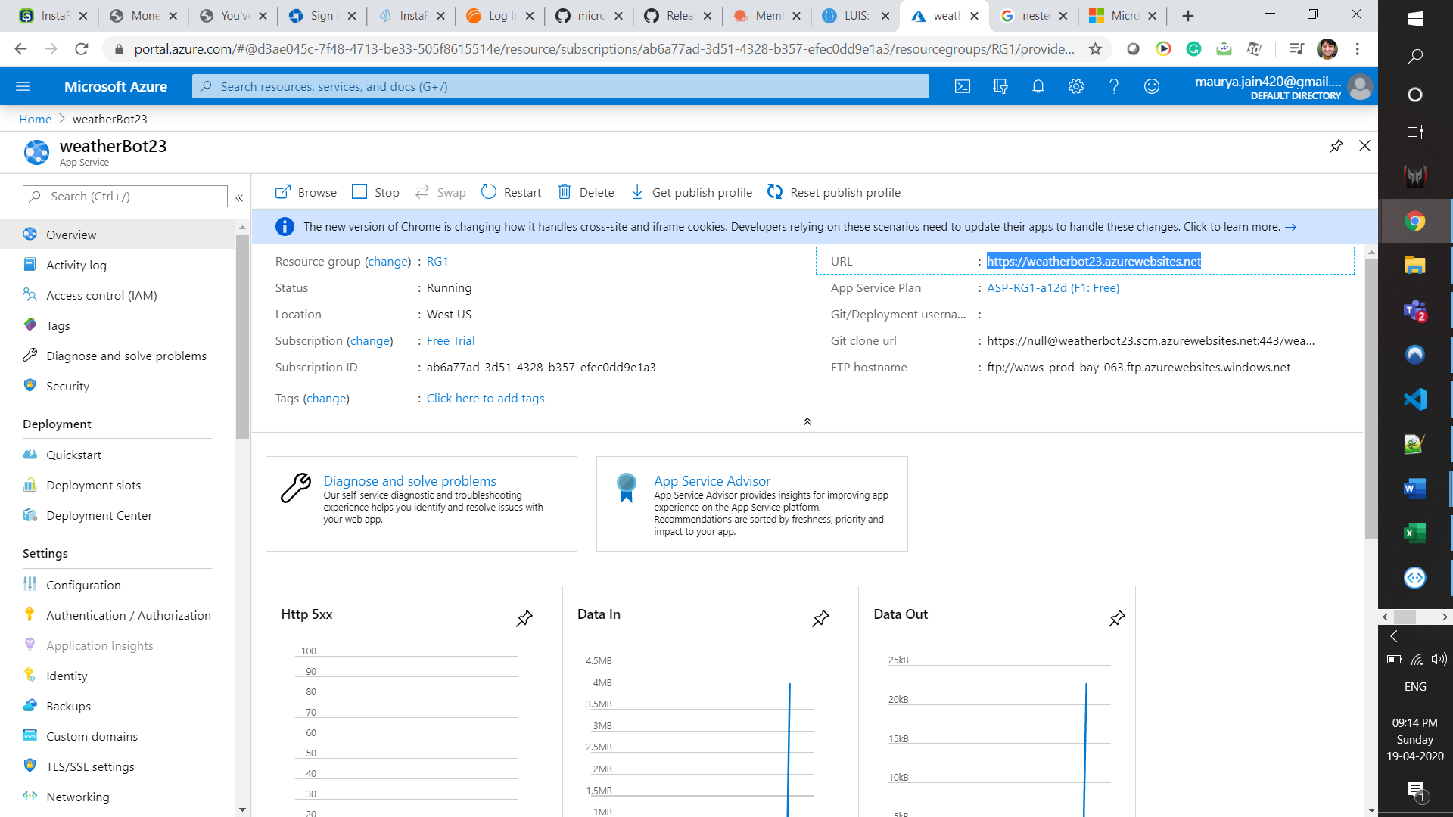

[https://weatherbot23.azurewebsites.net](https://weatherbot23.azurewebsites.net/)